6.15: a) parallel to incline: force component 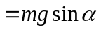, down incline; displacement 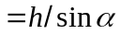, down incline
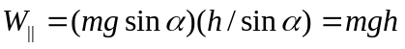 perpendicular to incline: no displacement in this direction, so 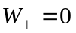.
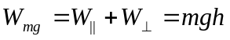, same as falling height h.
b) 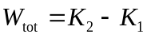 gives 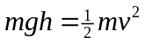 and 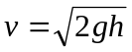, same as if had been dropped from height h. The work done by gravity depends only on the vertical displacement of the object.
When the slope angle is small, there is a small force component in the direction of the displacement but a large displacement in this direction. When the slope angle is large, the force component in the direction of the displacement along the incline is larger but the displacement in this direction is smaller.
c) 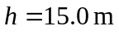, so 